Chapter 1: Structure and Bonding

1. | What is the ground-state electronic configuration of a carbon atom?
 | A) 1s², 2s², 2p⁵ B) 1s², 2s², 2p² C) 1s², 2s², 2p⁶ D) 1s², 2s², 2p⁴

2. | What is the ground-state electronic configuration of a fluorine atom?
 | A) 1s², 2s², 2p² B) 1s², 2s², 2p³ C) 1s², 2s², 2p⁴ D) 1s², 2s², 2p⁵

3. | What is the ground-state electronic configuration of a magnesium cation (Mg²⁺)?
 | A) | 1s², 2s², 2p⁶ | C) | 1s², 2s², 2p⁶, 3s²
 | B) | 1s², 2s², 2p⁶, 3s¹ | D) | 1s², 2s², 2p⁶, 3s², 3p²

4. | What is the ground-state electronic configuration of a chlorine anion (Cl—)?
 | A) | 1s², 2s², 2p⁶ | C) | 1s², 2s², 2p⁶, 3s², 3p⁵
 | B) | 1s², 2s², 2p⁶, 3s², 3p⁶ | D) | 1s², 2s², 2p⁶, 3s², 3p⁴

5. | Which of the following statements about valence electrons is true?
 | A) | They are the most tightly held electrons.
 | B) | They do not participate in chemical reactions.
 | C) | They are the outermost electrons.
 | D) | They reveal the period number of a second-row element.

6. | Which of the following statements about bonding is true?
 | A) | Covalent bonds result from the transfer of electrons from one element to another.
 | B) | Ionic bonds result from the transfer of electrons from a metal to a non-metal.
 | C) | Ionic bonds result from the sharing of electrons between two non-metals.
 | D) | Covalent bonds result from the sharing of electrons between two metals.

7. | Which of the following would you expect to have ionic bonds?
 | A) CO B) FBr C) NF₃ D) NaCl

8. | Which of the following molecules has nonpolar covalent bonds?
 | A) HCl B) N₂ C) CHCl₃ D) NO

9. | Which of the following molecules contain both covalent and ionic bonds?  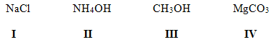
 | A) I, II B) I, IV C) II, III D) II, IV

10. | Arrange the following bonds in decreasing order of ionic character, putting the most ionic first.
 | A) | I > II > III > IV | C) | IV > III > II > I
 | B) | IV > II > I > III | D) | IV > II > III > I

11. | Which of the following statements correctly describes the typical number of bonds for carbon, nitrogen, and oxygen in most neutral organic molecules?
 | A) | Carbon forms 4 covalent bonds, nitrogen forms 2 covalent bonds and oxygen forms 3 covalent bonds.
 | B) | Carbon forms 4 covalent bonds, nitrogen forms 3 covalent bonds and oxygen forms 2 covalent bonds.
 | C) | Carbon forms 4 covalent bonds, nitrogen forms 5 covalent bonds and oxygen forms 2 covalent bonds.
 | D) | Carbon forms 4 covalent bonds, nitrogen forms 5 covalent bonds and oxygen forms 4 covalent bonds.

12. | Which is not an acceptable Lewis structure for the anion CH₂NCO—?  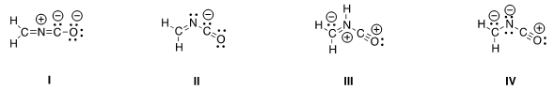
 | A) I B) II C) III D) IV

13. | Which of the following Lewis structures is correct?  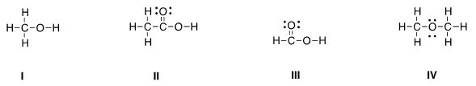
 | A) I B) II C) III D) IV

14. | Which of the following Lewis structures is correct?  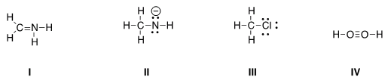
 | A) I, II B) I, III C) II, III D) III, IV

15. | Which is the correct Lewis structure for acetic acid (CH₃CO₂H)?  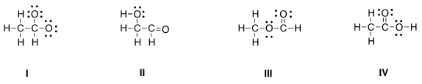
 | A) I B) II C) III D) IV

16. | In which of the following ions does carbon have a formal charge?  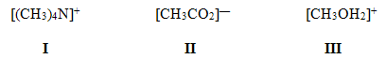
 | A) I B) II C) III D) None of the above

17. | In which of the following ions does carbon have a formal charge?  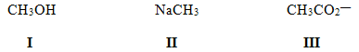
 | A) I B) II C) III D) None of the above

18. | What is the formal charge of carbon in carbon monoxide (CO) when drawn with a triple bond?
 | A) 0 B) -2 C) -1 D) +1

19. | Which of the following statements about constitutional isomers is true?
 | A) | Constitutional isomers are different molecules having different molecular formula.
 | B) | Constitutional isomers are different molecules having same molecular formula.
 | C) | Constitutional isomers are same molecules having different molecular formula.
 | D) | Constitutional isomers are same molecules having the same molecular formula.

20. | How many constitutional isomers are there for a molecule having the molecular formula C₂H₆O?
 | A) 1 B) 2 C) 3 D) 4

21. | How many constitutional isomers are there for a molecule having the molecular C₃H₈O?
 | A) 1 B) 2 C) 3 D) 4

22. | How many constitutional isomers are there for a molecule having the molecular formula C₃H₆?
 | A) 1 B) 2 C) 3 D) 4

23. | How many constitutional isomers are there for a molecule having the molecular formula C₂H₄Cl₂?
 | A) 1 B) 2 C) 3 D) 4

24. | How many different isomers are there for a compound having the molecular formula C₃H₆O?
 | A) 4 B) 5 C) 6 D) 7

25. | Which of the following molecules are constitutional isomers?  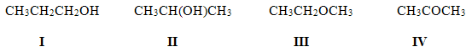
 | A) I, II, IV B) II, III, IV C) I, III, IV D) I, II, III

26. | Which of the following compounds has an atom with an unfilled valence shell of electrons?
 | A) H₂O B) BCl₃ C) CH₄ D) CO₂

27. | Which of the following statements about resonance structures is true?
 | A) | Resonance structures have the same placement of electrons but different arrangement of atoms.
 | B) | Resonance structures have the same placement of atoms but different arrangement of electrons.
 | C) | Resonance structures have the same placement of atoms and the same arrangement of electrons.
 | D) | Resonance structures have different placement of atoms and different arrangement of electrons.

28. | Which of the following statements about resonance structures is not true?
 | A) | There is no movement of electrons from one form to another.
 | B) | Resonance structures are not isomers.
 | C) | Resonance structures differ only in the arrangement of electrons.
 | D) | Resonance structures are in equilibrium with each other.

29. | Which of the following pair does not represent resonance structures?  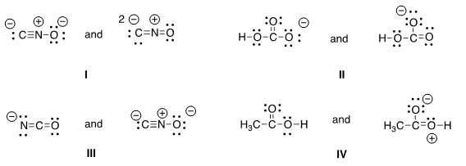
 | A) I B) II C) III D) IV

30. | What 2 things will change between two resonance structures?
 | A) | The position of multiple bonds and non-bonded electrons.
 | B) | The position of multiple bonds and single bonds.
 | C) | The placement of atoms and single bonds.
 | D) | The placement of atoms and non-bonded electrons.

31. | Which of the following is a resonance structure of the compound below?  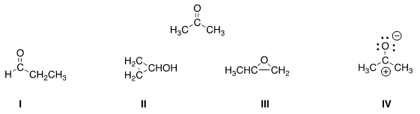
 | A) I B) II C) III D) IV

32. | Which of the following resonance structures is the least important contributor to the resonance hybrid of the formate anion, HCOO—?
 | A) I B) II C) III D) IV

33. | Rank the following in order of decreasing importance as contributing structures to the resonance hybrid of formaldehyde, H₂CO.  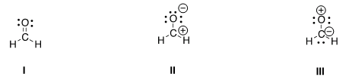
 | A) I > II > III B) I > III > II C) II > I > III D) III > II > I

34. | Follow the curved arrows to draw the second resonance structure for the ion below.  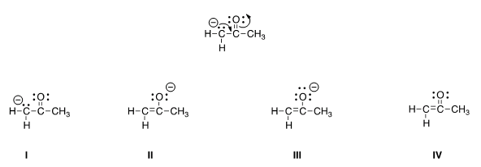
 | A) I B) II C) III D) IV

35. | Which is more important in each pair of contributing resonance structures?  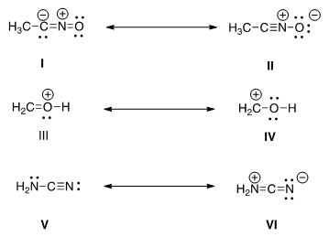
 | A) II, IV, V B) II, III, V C) II, III, VI D) I, IV, V

36. | What is the approximate value of the H-C-H bond angle in methane, CH₄?
 | A) 90° B) 109.5° C) 120° D) 180°

37. | What is the approximate C-C-C bond angle in propene, CH₃CH=CH₂?
 | A) 90° B) 109.5° C) 120° D) 180°

38. | What is the approximate H-C-O bond angle in formaldehyde, H₂CO?
 | A) 90° B) 109.5° C) 120° D) 180°

39. | Determine the electron geometry around the indicated atom in each species.  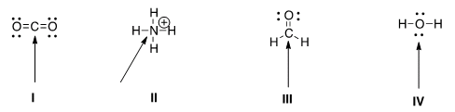
 | A) | I = Linear; II = tetrahedral; III = trigonal planar; IV = tetrahedral
 | B) | I = Linear; II = tetrahedral; III = trigonal planar; IV = linear
 | C) | I = Trigonal planar; II = linear; III = tetrahedral; IV = trigonal planar
 | D) | I = Tetrahedral; II = trigonal planar; III = linear; IV = tetrahedral

40. | What is the approximate bond angle for the C-C-N bond in acetonitrile, CH₃CN?
 | A) 90° B) 109.5° C) 120° D) 180°

41. | Which of the following is the appropriate conversion of the condensed structure, CH₃COCH₃, to a Lewis structure?  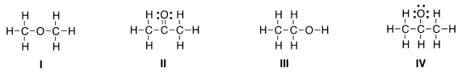
 | A) I B) II C) III D) IV

42. | Which of the following is the appropriate conversion of (CH₃)₂CHCH₂CHClCH₃ to a skeletal structure?  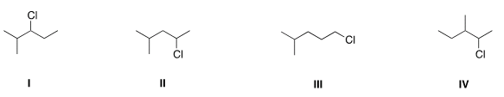
 | A) I B) II C) III D) IV

43. | Which of the following is the appropriate conversion of (CH₃)₄C to a skeletal structure?
 | A) I B) II C) III D) IV

44. | What is the condensed formula of the compound below?  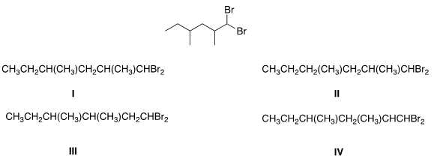
 | A) I B) II C) III D) IV

45. | Which of the following is the appropriate conversion of (CH₃)₂CHOCH₂CH₂CH₂OH to a skeletal structure?  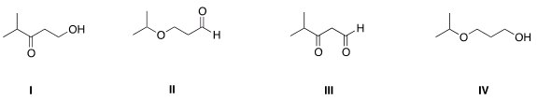
 | A) I B) II C) III D) IV

46. | Convert the following skeletal structure to a condensed structure.  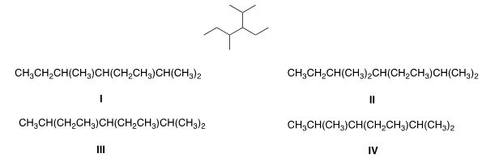
 | A) I B) II C) III D) IV

47. | Avobenzone is an active ingredient in some common sunscreens. Which of the following is the correct molecular formula for avobenzone?  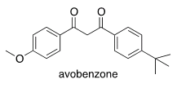
 | A) C₂₂O₂₂O₃ B) C₂₀H₂₂O₃ C) C₂₁H₂₃O₃ D) C₂₀H₂₄O₃

48. | In which structure is the hybridization incorrect?  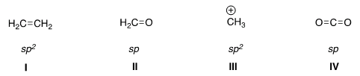
 | A) I B) II C) III D) IV

49. | What is the hybridization for each of the indicated atoms in the following compound?  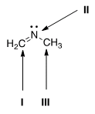
 | A) | I = sp²; II = sp²; III = sp². | C) | I = sp; II = sp²; III = sp³.
 | B) | I = sp²; II = sp³; III = sp³. | D) | I = sp²; II = sp²; III = sp³.

50. | What is the hybridization of the carbon atom in the methyl cation, (CH₃⁺)?
 | A) sp³ B) sp² C) sp D) p

51. | What is the hybridization of the nitrogen atom in the ammonium cation, NH₄⁺?
 | A) sp³ B) sp² C) sp D) p

52. | Which atomic orbitals overlap to form the C-H σ bonding molecular orbitals of ethane, CH₃CH₃?
 | A) Csp² + H1s B) Csp³ + H1s C) C2p + H1s D) Csp + H1s

53. | Which atomic orbitals overlap to form the C-H σ bonding molecular orbitals of ethylene, H₂C=CH₂?
 | A) C2p + H1s B) Csp + H1s C) Csp³ + H1s D) Csp² + H1s

54. | Which atomic orbitals overlap to form the carbon-carbon σ and π bonding molecular orbitals of ethylene, H₂C=CH₂?
 | A) | Csp³ + Csp³, and C2p + C2p | C) | Csp² + Csp², and C2p + C2p
 | B) | Csp³ + Csp³, and Csp² + Csp² | D) | Csp² + Csp², and Csp² + Csp²

55. | Which atomic orbitals overlap to form the C-H σ bonding molecular orbitals of acetylene, C₂H₂?
 | A) Csp + H1s B) C2p +H1s C) Csp³ + H1s D) Csp² + H1s

56. | Which atomic orbitals overlap to form the carbon-carbon σ bonding molecular orbital of acetylene, C₂H₂?
 | A) Csp² + Csp² B) Csp + Csp C) Csp³ + Csp³ D) C2p + C2p

57. | When forming molecular orbitals from atomic orbitals, what is the order of increasing C-H bond strength for the following.  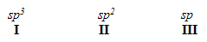
 | A) II < I < III B) III < I < II C) III < II < I D) I < II < III

58. | What is the order of decreasing bond length for a C-C bond comprised of the following molecular orbitals?  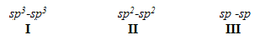
 | A) I > III > II B) I > II > III C) III > II > I D) II > III > I

59. | Which of the following statements about electronegativity and the periodic table is true?
 | A) | Electronegativity decreases across a row of the periodic table.
 | B) | Electronegativity increases down a column of the periodic table.
 | C) | Electronegativity increases across a row of the periodic table.
 | D) | Electronegativity does not change down a column of the periodic table.

60. | Rank the following atoms in order of increasing electronegativity, putting the least electronegative first.
 | A) | I < II < III < IV | C) | III < II < IV < I
 | B) | I < IV < II < III | D) | I < II < IV < III

61. | Rank the following atoms in order of decreasing electronegativity, putting the most electronegative first.
 | A) | I > IV > II > III | C) | III > IV > II > I
 | B) | II > III > IV > I | D) | III > II > IV > I

62. | Which molecule has the greatest difference in electronegativity (ΔE) between the two different elements?
 | A) CO₂ B) H₂S C) NH₃ D) H₂O

63. | Which compound contains the most polar bond?
 | A) I B) II C) III D) IV

64. | Which of the following compounds are non-polar?
 | A) I, IV B) I, II C) II, III D) II, IV

65. | Which of the following molecules has non-polar covalent bonds?
 | A) CO₂ B) N₂ C) CCl₄ D) HF

66. | Which of the following molecules has polar covalent bonds?
 | A) MgO B) NH₃ C) Cl₂ D) NaBr

67. | Which of the following covalent bonds has the largest dipole moment?
 | A) C-H B) C-C C) C-O D) H-F

68. | Which of the following molecules has the smallest dipole moment?
 | A) CO₂ B) HCl C) H₂O D) NH₃

69. | Which of the following molecules does not have a net dipole moment of zero?
 | A) CCl₄ B) BF₃ C) CO₂ D) NH₃

70. | Which of the following molecules has a net dipole moment of zero?
 | A) I B) II C) III D) IV

Answer Key

1. | B
2. | D
3. | A
4. | B
5. | C
6. | B
7. | D
8. | B
9. | D
10. | C
11. | B
12. | C
13. | D
14. | C
15. | D
16. | D
17. | B
18. | C
19. | B
20. | B
21. | C
22. | B
23. | B
24. | D
25. | D
26. | B
27. | B
28. | D
29. | C
30. | A
31. | D
32. | B
33. | A
34. | C
35. | B
36. | B
37. | C
38. | C
39. | A
40. | D
41. | B
42. | B
43. | D
44. | A
45. | D
46. | A
47. | B
48. | B
49. | D
50. | B
51. | A
52. | B
53. | D
54. | C
55. | A
56. | B
57. | D
58. | B
59. | C
60. | B
61. | D
62. | D
63. | B
64. | A
65. | B
66. | B
67. | D
68. | A
69. | D
70. | B

